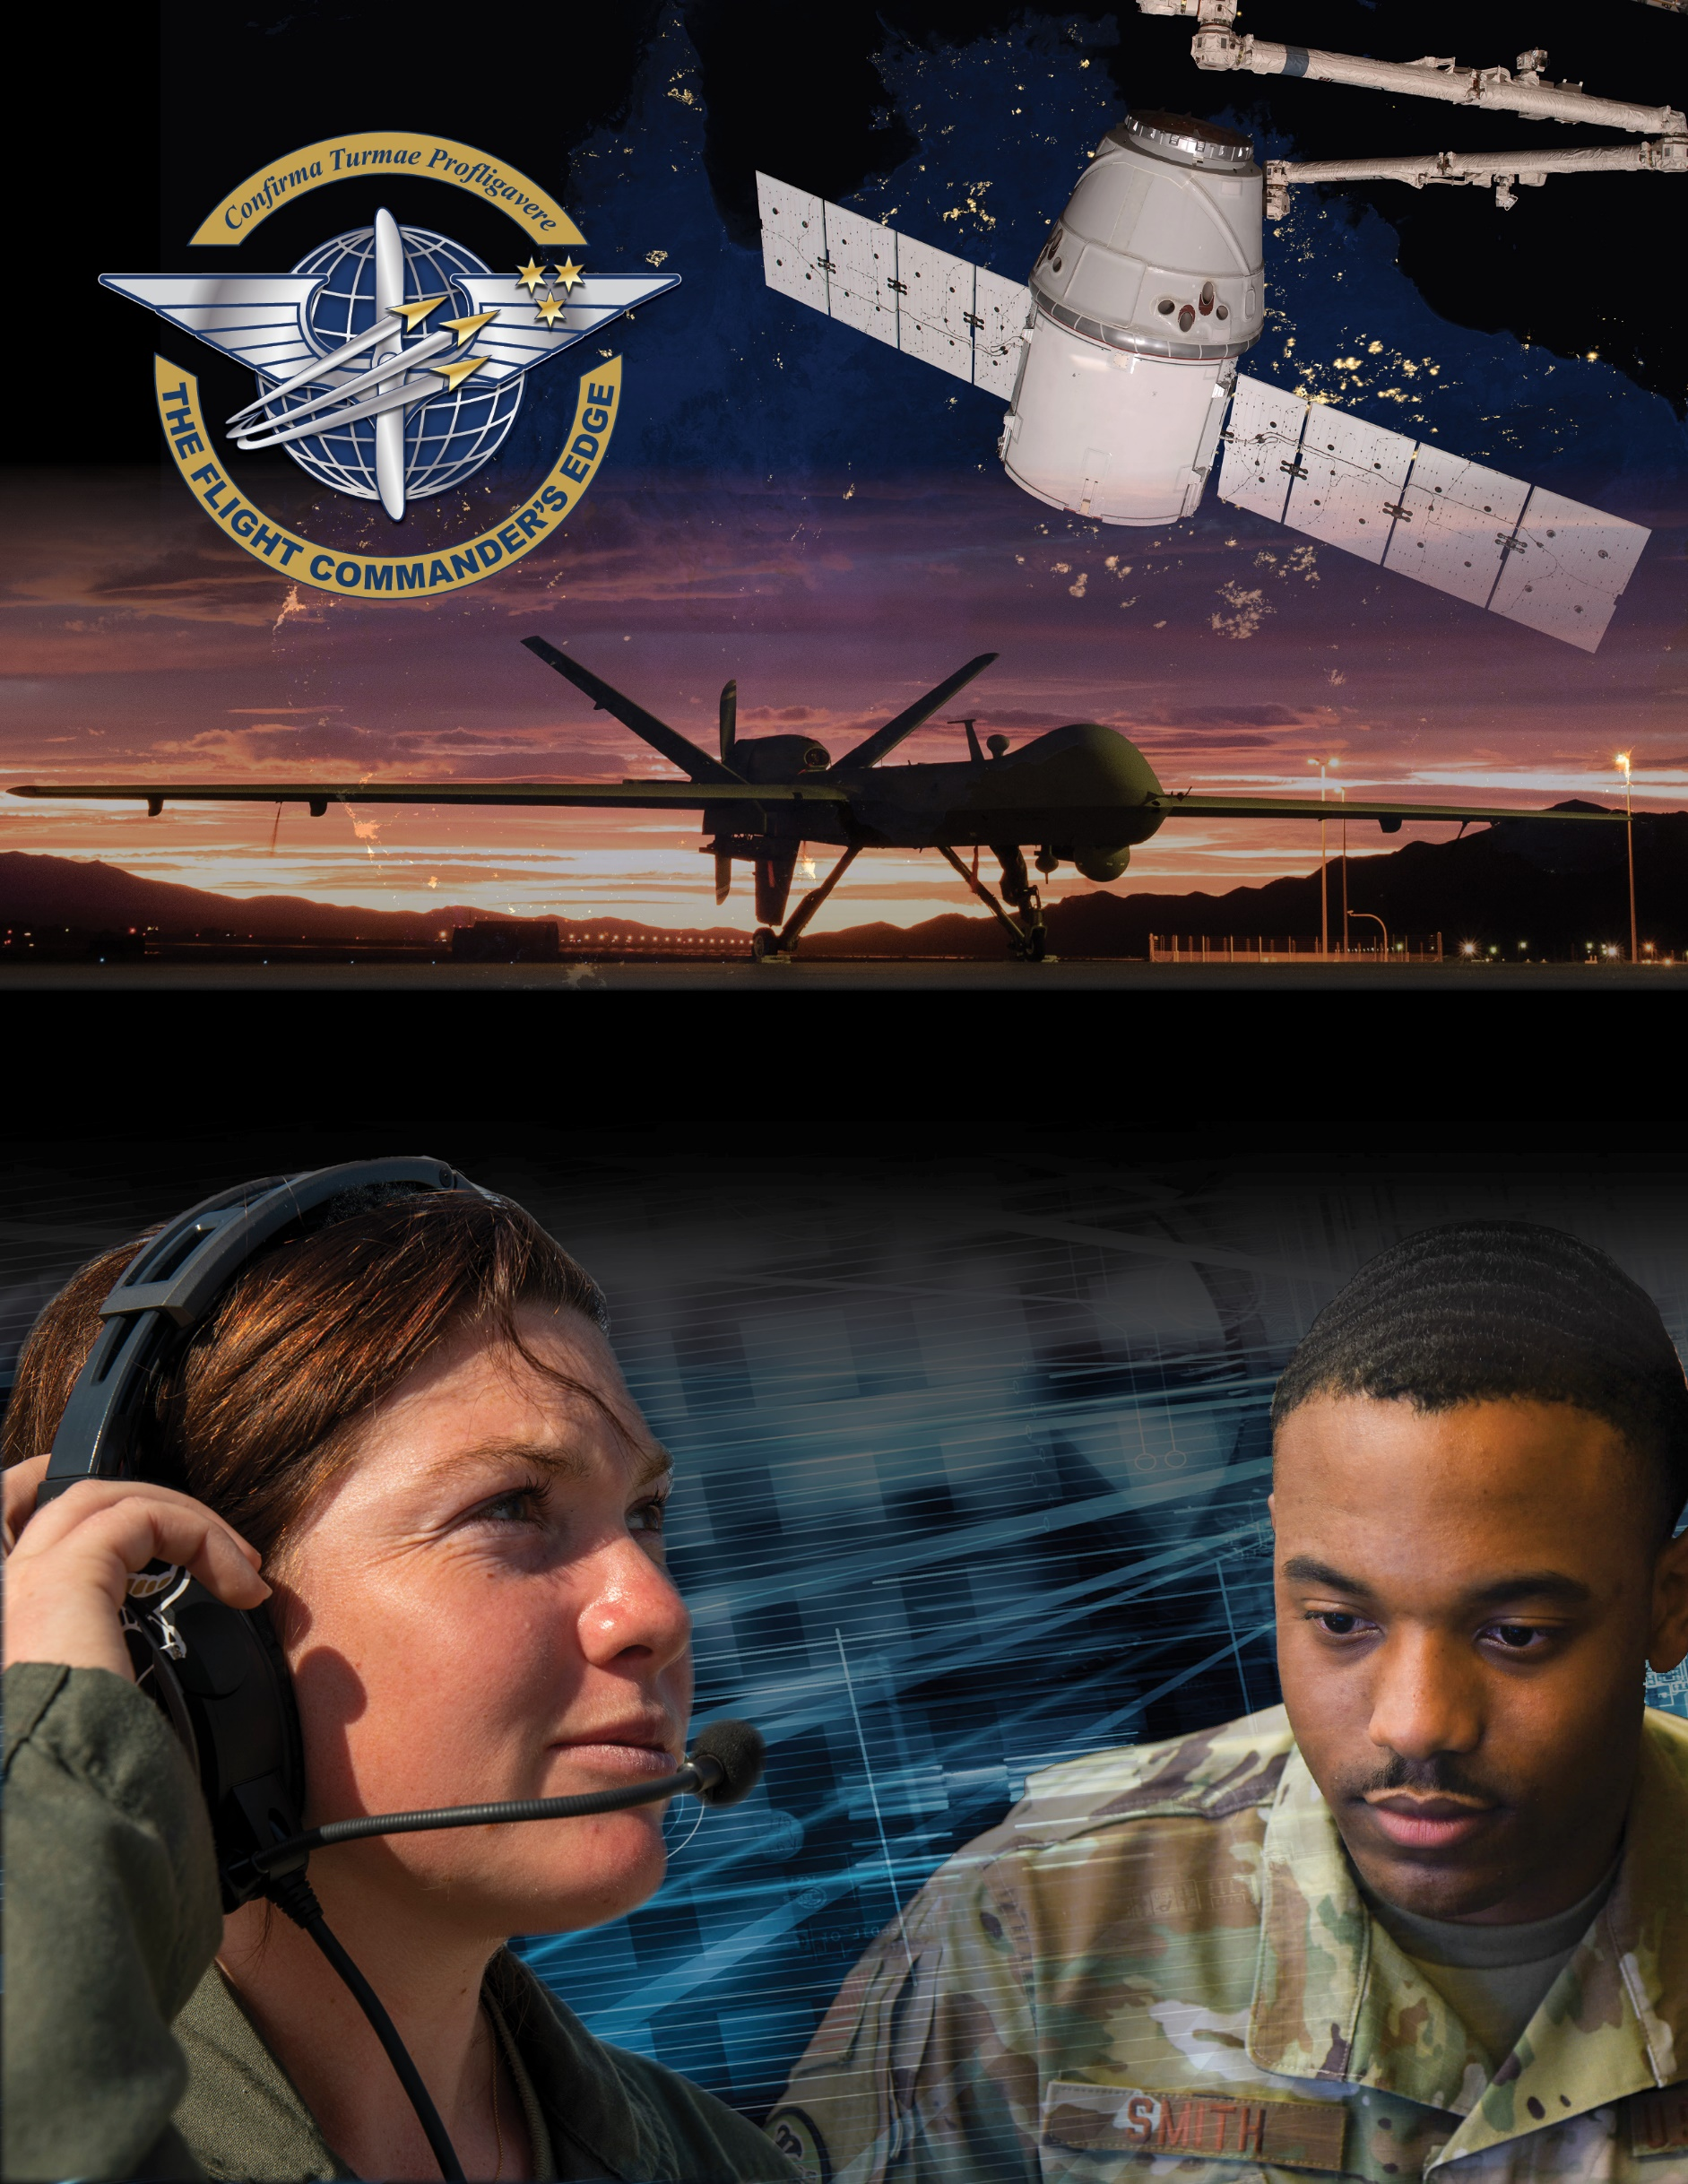

**Lesson Guide**



**Organizational Structure and the Mission**

**14 April 2025**

**Organizational Structure and the Mission**

### Purpose

This lesson guide is designed to support the local development of Flight Commander Leadership Course materials. Selected facilitators should use this guide as they prepare presentation materials. For more information on how lessons are structured, or how to use them in the course, see the ***Course Director’s Handbook*** or online Facilitator Resources.

### Scope

### An organization’s structure and mission are interconnected. The mission describes an organization's purpose-what everyone within the organization is working toward. Changes in the mission drive changes in the structure of the organization to accomplish the mission more effectively. Organizational structures across wings, deltas or garrisons are inherently different, supporting different missions and affecting how operations and the exchange of information occur at different bases. Understanding the mission is the first step towards recognizing the role of each organization in reaching success across the Department of the Air Force.

### As a Flight Commander, it is important to know and understand your organizational structure but also the critical role your flight and squadron (or equivalent) play in accomplishing the mission of the broader organization. You must message this “why” down to the lowest levels of the flight in order to keep your Airmen or Guardians engaged and connected to the vital role they play in the mission. Additionally, a Flight Commander must recognize where he/she fits into the chain-of-command as issues may arise which require them to not only go up and down the chain but often laterally outside of the local unit to resolve.

### Recommended Objectives

By the end of this lesson, the participant should be able to:

### Explain your unit’s (wing/equivalent) mission and how a mission promotes unity of effort.

### Describe your unit’s (wing/equivalent) organizational structure and its purpose.

### Define the role of your Flight and/or squadron/equivalent in fulfilling the wing's overall mission.

### Recommended POC / Presenter

* Group/Wing, Delta or Garrison-level leader (CC or CV if possible)
* Squadron-level leader (DO, CC or equivalent)

### Recommended Length:

* 25 minutes (inclusive of questions)

### Recommended Approach

* Informal briefing and discussion

### Lesson Connections

* **Organizational Heritage**-it is important to recognize how technology and emerging threats have altered the mission of each wing, delta or garrison and how these have transformed in order to more effectively accomplish dynamic DAF missions.
* **Mission Command**-innovation, flexibility, and trust are key factors in accomplishing the mission with limited resources and would not be possible without a clear commander’s intent or individual initiative.
* **Preparing for Command**-it is critical for you as a Flight Commander to understand the flight/squadron’s mission in the context of the wing’s mission and be able to message the critical role of your flight/squadron to your team.